Appendix 4.0 – Incident Report

Foreman |  |  | Job Site:
Date of Incident (DD/MM/YY) | Time of Incident  AM PM |  | Time Foreman Notified  AM PM
Please indicate the appropriate Event Type (all that apply)
- Personal Injury | - Equipment or Vehicle Damage |  | - Utility Contact |  | - 3rd Party Damage
- Theft/Vandalism

Nature of illness/Accident/Contact/Damage/Theft/etc. (explain what happened)
Loss Severity Potential |  |  | Probability of Reoccurrence
Major Serious Minor |  |  | Often Occasional Seldom
Indicate Part of Body Injured (Circle part of body) |  |  | Notes - Diagrams
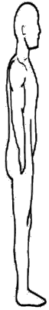
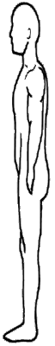
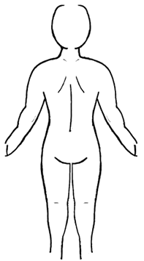
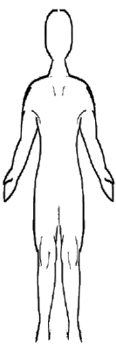
Object/Equipment/Substance Involved |  |  | Location of Incident
- First Aid  - Medical Aid | Provide By: |  | Was transportation provided to the Hospital/Clinic/Family Doctor?  Ambulance Foreman Insured Worker None
Did the injured return to work on the same day?  Yes No |  |  | Has the employee had a previous similar disability?  Yes No
Will the employee require modified duties?  Yes No |  |  | Was any NON-employee totally or partially responsible?  Yes No
Worker realizes light duty is available with no pay loss?  Yes No |  |  | Any serious and willful misconduct involved?  Yes No
Will the employee be totally or partially disabled?  Yes No |  |  | At the time of injury, was the employee doing work other than what he was hired for?  Yes No
Type of Contact (check all applicable) |  |  | Contact With
- Struck Against  - Struck by Caught In  - Fall on Same Level | - Caught On  - Caught between Slip  - Fall to Below Overexertion |  | - Electricity Radiation  - Heat/Cold |  | - Caustic/Toxic or Noxious Substance  - Noise
Coding Immediate Causes (Check all applicable)
Substandard Actions |  |  | Substandard Conditions
- Operating Equipment without authority  - Failure to warn  - Failure to secure  - Operating at improper speed making safety device inoperable  - Removing safety devices  - Using defective equipment  - Using equipment improperly | - Failure to use PPE properly  - Improper loading  - Improper placement  - Improper lifting  - Improper position for task servicing equipment in operation  - Horseplay  - Under influence of Alcohol and/or drugs |  | - Inadequate guards or barriers  - Inadequate of improper PPE  - Defective tools, equipment or materials  - Congestion or restricted action  - Inadequate warning system  - Fire and explosion hazard  - Poor housekeeping |  | - Hazardous environment conditions  - Noise exposure  - Radiation exposure  - High/Low temperature exposure  - Inadequate or excessive illumination  - Inadequate ventilation
Coding of Basic Causes (check all applicable)
Personal Factors |  |  | Job Factors
- Inadequate capability  - Lack of knowledge  - Lack of skill | - Stress  - Improper motivation |  | - Inadequate leadership/ supervision  - Inadequate engineering  - Inadequate purchasing  - Inadequate maintenance |  | - Inadequate tools/equipment  - Inadequate work standards  - Wear and tear  - Abuse and misuse
Remedial Actions. What has and/or should be done to control the causes listed?
1.
2.
3.
4.
5.
6.
Witness (1)  Print Name:  Sign: |  | Witness (2)  Print Name:  Sign: |  | Witness (3)  Print Name:  Sign:
Ministry of Labour Notified  Yes No | Time Notified  AM PM |  | Date Notified (dd/mm/yy) |  | By Whom
Reason Why or Why Not?
Recommendation attached?  Yes No | Report to be Filed  Yes No |  | If Yes, where:

Investigators Name (Print) ________________________________________________________

Signature ______________________________________________________________________

Date (dd/mm/yy) ________________________________________________________________

Reviews of Recommendations & Accident Investigation Report

Health and Safety Representative
Signature | Date (dd/mm/yy)
Health and Safety Committee (management and worker) review required? | Yes No
Worker’s Signature | Date (dd/mm/yy)
Management’s Signature | Date (dd/mm/yy)
Senior Management Review Required? | Yes No
Signature | Date (dd/mm/yy)
Remedial Action Review. Overall Response and follow-up to proposed remedial actions
Signature of Person(s) responsible for Implementation
Print Name:  Sign:  Date (dd/mm/yy) | Print Name:  Sign:  Date (dd/mm/yy)
Print Name:  Sign:  Date (dd/mm/yy) | Print Name:  Sign:  Date (dd/mm/yy)
Print Name:  Sign:  Date (dd/mm/yy) | Print Name:  Sign:  Date (dd/mm/yy)

Final Outcome relating to incident:

